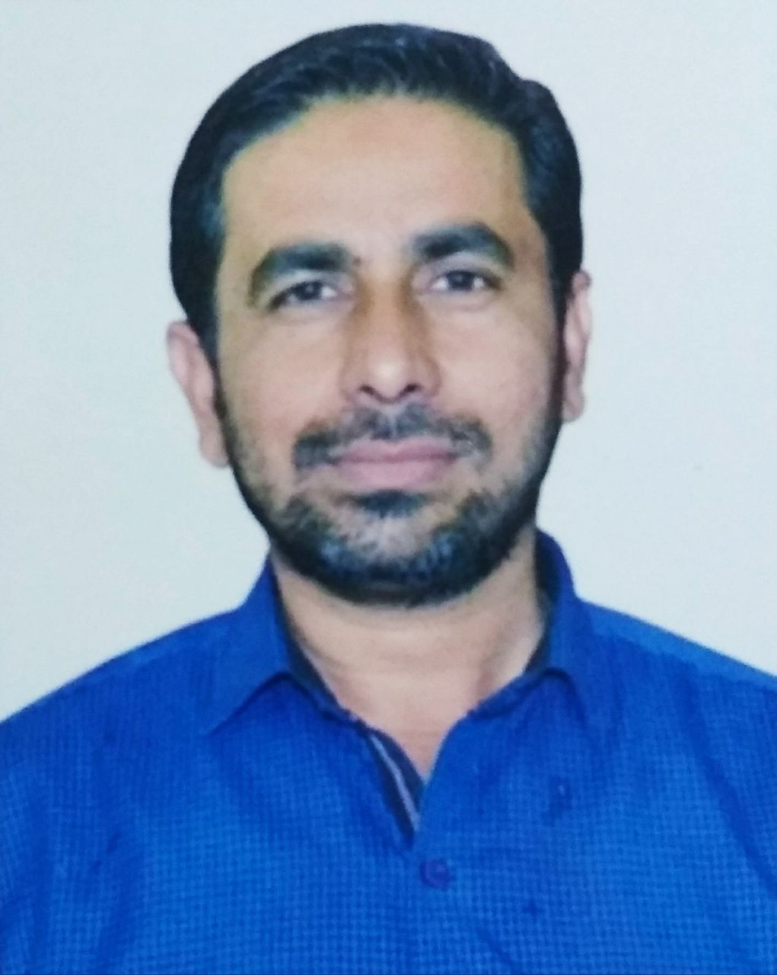

Dr. Md. Jawed

Okhla, New Delhi- 25

Email ID: javed83jmi@gmail.com

Mobile Number: 91-9718432074/9015452847

Profession profile
A professionally qualified Post Graduate Diploma in management of NGOs from Jamia Millia Islamia University, Delhi. And More than Five years of progressive, professional experience in the field of Education, community empowerment, Health, Livelihood, Training, placements and office management in the Development projects.

Education

PhD in International Relations, Topic: Gulf Migration and Social Change in India, from JAMIA MILLIA ISLAMIA University (JMI), New Delhi, INDIA

M. Phil in International Relations | 2010 | Topic: International Migration from India from JAMIA MILLIA ISLAMIA University (JMI), New Delhi, INDIA

Post Graduate Diploma in Management of NGO’s | 2008 | JAMIA MILLIA ISLAMIA (JMI), New Delhi, INDIA

MA in Sociology | 2007 | AMU, UP, INDIA

B. Sc. (Hons.) in Anthropology | 2003 | VINOBA BHAVE UNIVERSITY, HAZARIBAGH, JHARKHAND INDIA

Intermediate of Science (I. Sc.) | 2000| BIHAR EDUCATION COUNCIL, Patna, BIHAR, INDIA

Secondary Examination | 1998| NIOS, BOKARO STEEL CITY, JHARKHAND, INDIA

Working Experience:

*1. Worked as a Coordinator | BOSCO Delhi (Don Bosco), Okhla, New Delhi, INDIA

Projects: UNHCR-BOSCO Refugee Assistance Project and Self Reliance Programmes

- Major Responsibilities:
Community Mobilisation, Liasoning with Government departments, Emergency support to the Beneficiaries, Child protection, Education, Health and Advocacy and community Empowerment.

- Looking after, Community mobilisation, Education, Child protection and Health programs sponsored by UNHCR,
- Need based assessment and situational analysis
- Networking with UNHCR and other associated organizations
- Overall monitoring and evaluation of the mentioned Projects
- Coordinate community service provider with regard to access a health services at Govt. Hospital
- Conduct various Health camps for the children: Health and hygiene, waterborne disease-Dengue, diarrhoea, Malaria and other seasonal disease
- Social Advocacy and Campaign, Community Mobilization
- Coordinate Open house meeting between Donor, Implementing partners and beneficiaries
- Arrange a Leaders meeting once in a month at Community to run a project smoothly and update the community with new information’s
- Arrange a Meeting/Sessions/Trainings with Women group at Community
- Facilitate rapport building with host community
- Facilitate police sensitization programme
- Conducted Vocational Training Programs for the youth and children
- Conducted Job Oriented sessions with the Job Seekers for understanding of wok culture.
- Coordinated job seeker training for better livelihood option to the community members.
- Conducted placement trainings and offered various jobs to the beneficiaries.
- Organized the campus interviews at the centre and community’s locations.
- Conducted Employers meet in order to build a rapport between employer and
- Conduct regular meetings/interactions with employers
- Coordinated and guide them for small business grants, sponsorships programme and income generating activities.
- Coordinated Financial Literacy Training for the Business Grant Participants
- Coordinated Business development workshop Training for the Participants
- Home visits, case studies and documentations.
- Organise awareness session on seasonal disease
- Organise awareness session on substance abuse
- Organise sanitation drive among children and women participants in the community
- Coordinated admission processes for various courses
- Coordinated with the teachers, community members and animators.
- Facilitation of school enrolment (Government)
- Coordinated crèche classes
- Coordinated Bridge classed
- Coordinated tuition classes
- Facilitated parents teacher meeting in the community
- Arrange a Child Club Meeting at Community once in a month
- Monthly Follow up of the school Going Children
- Coordinated Youth Meets, Sports Meets, AIDS Rally, Educational, Cultural meets for the children and others campaigns.
- Documentation-Weekly, Monthly, Quarterly and annual reports.
- Writing project proposal for the Community Project/Social Project
- Monthly Evaluation of on Going Community/Social Project for the Participants
- Liaisoning with Government officers for make services available for the Beneficiaries (e.g., proper supply of drinking water, Frequent fogging in the area to prevent disease like Malaria and Dengue, Fire safety Training in the community)
- Attended training on SGBV (Sexual and Gender based Violence) at Indian social Institute Lodhi Road, New Delhi, under the centre for Refugees Research, Australia
- Attended Workshop on Child Protection under the SAARD organisation, New Delhi, India
- Liaoning with CMO and Doctors at Govt. Hospital for build a rapport
- Arrange House hold survey for the school enrolment

**2. Worked as a Social Worker | SALAAM BAALAK TRUST, New Delhi, INDIA |

Projects: Provides a Sensitive and Caring Environment to Street and Working children in

Delhi

Major Responsibilities
- Reaching out to new children
- Counseling children to return to their families and helping trace them
- Peer education programme provides an interface between new arrivals and children having a long association with SBT; the older children talk about their journey from the streets to SBT. This creates a sense of common identity and empathy between the old children and the new, resulting in many children consenting to regularly visit our Contact Points
- Providing nutrition, clothing and toilet facilities
- Education: non-formal, formal and open school
- Comprehensive medical support
- Counseling and referral to drug addiction programmes
- Recreational facilities: art and craft, music, outdoor and indoor games, local excursions, and annual holidays in the hills
- Creating awareness on child rights and promoting adherence
- Fostering a sense of communal harmony and an awareness of other religions through observance of all major festivals
- Sensitisation of key stake holders
- Networking with authorities such as law, enforcement agencies, local civic bodies and railways
- Sensitisation of adults who live on the streets with their children
Restoring children back to their families.

Research Experience
- Worked as Research Investigator in the Project “Baseline Survey in the Minority Concentrated Districts of India” Sponsored by Ministry of Minority Affairs.
- Worked as a Research Investigator in the Project of “Rajiv Gandhi drinking water Augmentation Scheme” Commissioned by the Govt. of Haryana from Dec 2009 to April 2010.
- Conducted Focussed Group Discussions in the Organisation
- Coordinated Participatory assessment Programme with the Beneficiaries
- Attended Three Days Community Development Workshop at Institute of Social Studies at New Delhi

Professional Development
- Right based approach to support refugee communities from BOSCO-UNHCR-2013.
- High Risk Identification tools from UNHCR Delhi-2013.
- Developing livelihood strategy from BOSCO-UNHCR-2013
- Situational Analysis from BOSCO-UNHCR-2013
- Effective leadership from BOSCO- Delhi-2012.
- Sexual Gender Based violence from SLIC, New Delhi-2012.
- Attended Community Development Workshop

Computer Skills
- MS Office - Word, Excel, Power Point, Outlook, Internet Browsing.

Personal Details
- Father’s Name: Md. Azimullah
- Mother Name: Shakila Bano
- Date of Birth: 29-10-1981
- Sex: Male
- Marital Status: Married
- Language Known: English, Hindi, Urdu & Bangla
- Permanent Address: Village: Murgia Chak, PO: Tajpur, District: Samastipur, BIHAR, INDIA.

Place: New Delhi

